**Branding and logo design**

As a reflection of your company's reputation, beliefs, purpose, and strengths, your brand may be used to consolidate these concepts in the minds of customers—and the workers who serve them. Because it can leverage to build a loyal customer base through traditional and online media, a strong brand is a basis for a successful marketing plan.

Creating an outstanding logo for a business is an essential part of its corporate identity development process, market positioning strategy, and overall company competitive advantage. Most businesses, corporate groups, entities, and prominent individuals use logos across the globe to convey short statements and encourage rapid public recognition. An excellent company logo is the initial visual expression of what your firm is all about.

Your new logo will enhance your brand image, increase your company's visibility, and eventually result in more consumers and sales.

**We create the perfect brand for your business**

The agency strives to make companies shine by adopting high-quality designs in its portfolio. We are skilled at creating designs that draw attention, turn heads, and leave you speechless with their immense elegance and grace. The procedure for creating designs is simple.

**We won’t stop until you’re besotted with your new design!**

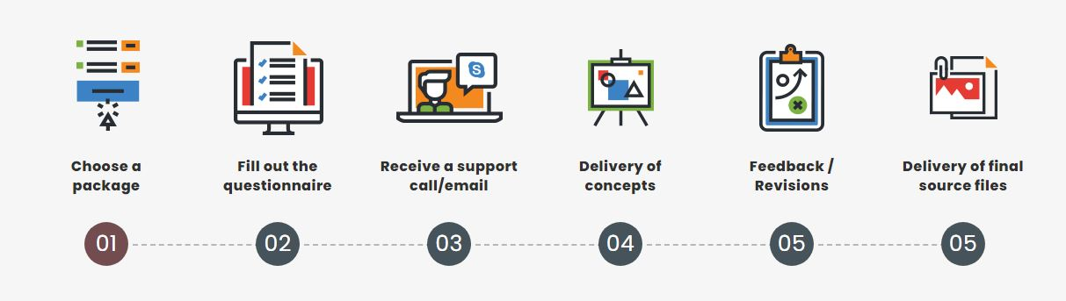

**Note:- Check url**: <https://www.brandsdesign.com/logo-design>

**Brand Startup Packages**

We believe in providing affordable brand and logo design services to all. Hence, here we have for you some great custom design packages to choose from

**SME Professional**

**Design + Print**

**N140,000**

**Branding**

- 2 Logo Design Concepts

- 500 Business Card Print

- 500 Letterhead Print

- 4 Employee ID Card Print

- 500 Promotional Flyer

- 5 Booklet Invoice Print

- Company seal

**Delivery**

18 Working Days

**SME Corporate**

**Design + Print**

**N55,000**

**Branding**

- 2 Logo Design Concepts

- 200 Business Cards Print

- 200 Letterhead Print

- 2 Employee ID Card Print

- 200 Promotional Flyer

**Delivery**

13 Working Days

**SME Kickstart**

**Design Only**

**N25,000**

**Branding**

- 2 Logo Design Concepts

- Business Card Design

- Letterhead Design

- Employee ID Card Design

**Delivery**

5 Working Days

ORDER NOW

ORDER NOW

ORDER NOW

**Got Questions? We Can Help**

**When I make an order what next?**

Immediately we are notified of your order activation, we call or mail you to get all necessary details.

After your job has been executed, it will be delivered to your address if it is not a virtual or digital product. Otherwise, we will send you our informative project documentation where you can find all necessary details on how to use the product.

**When and how do I pay for the work?**

We’ll get started with a no obligation phone call. If we’re the right fit for you, we’ll send a project contract for you to sign. We’ll send your first invoice (50% of the project fee) once we receive your contract. Once we’ve locked in your logo concept together, we’ll send the final 50% invoice.

**Are there hidden charges to your services?**

No, not at all! The prices we list on our website are all there is to the price except you want to upgrade a service or renew services that are on subscription.

**When can I expect to have my completed package?**

Each package is listed with its delivery timeframe. We run strict processes to be able to meet these deadlines. It’s important that you’re across the timeline so we can incorporate your feedback into our work. When we work together, we can finish the project sooner than later.

**Do you offer unlimited revisions?**

No. My time (and yours) is limited, and we believe that a responsible process narrows focus and helps us to avoid pursuing dead-end concepts and ongoing changes. Typical projects go through one or two rounds of fairly minor revisions because of this process

**Can I present my ideas and you could work on them for me?**

Absolutely! We encourage that our clients share their ideas and suggestions with us, so that we create exactly what you are looking for. You can share your ideas and we will design your logo as per your requirements.

**What if I am not satisfied with your job?**

We have served numerous brands and none has showed dissatisfaction with our job. However, if you break the record, we will do everything within our power to see that we make it up to you.

**What is the client’s involvement in the design process?**

We listen to our clients from the start. We encourage the client to bring in any samples, color combinations/swatches, and ideas they may have to help us get an idea of style before starting to work with new clients. During the design process, the client is asked to approve certain colors and fonts before work continues. Once the design project is ready for print we will submit a final proof for the customer’s approval before submitting to production. Once a job is in production, the job cannot be cancelled. At the conclusion of a project, the client may request the artwork in various formats if payment was made for design services.

**How will i receive my design project once it is finished?**

A finished project is yours upon receipt of final payment. At your request, we will supply the electronic files to you through your e-mail. We also keep a copy of your project on file for later updates or should you lose your copy.

**Do you offer SME Package to businesses outside Nigeria?**

Of course! We are a global business and that is why we exist on the internet after-all! However, delivery of flyers, business cards and other physical goods applies to Nigeria only.

**LETS DISCUSS YOUR COMPANY VISION AND BRANDING NEEDS**

CONTACT US FOR A FREE BRAND CONSULTATION